Clifford Joseph William Hine (1920-1997) born in Rochford, Essex. Parents Joseph Walter Hine and Louisa Maud (nee Pumfrey).
13 Feb 1937: Joined Anglo-Saxon Oil Co. in Accounts Dept. Cliff eventually retired from Shell on 24 August 1972 (36 years service), during which he served as an active RAF Reservist until 1970 (completing over 28 years service with the RAFVR reaching Squadron Leader rank as an RAF Provost Officer).
27 Jan 1938 Cliff joined Metropolitan Special Constabulary, HQ Central Division, "Shell" Company, New Scotland Yard, Division H2C Warrant Card No 008496H (occupation at Shell: accountant)
23 June 1939 Cliff joined the R.A.F.V.R. on 23 June 1939 and mobilised on 1 Sep 1939. Cliff was accepted for pilot training initially then transferred to air gunner training.
10 Aug - 6 Sept 1940 • No 8 Bombing & Gunnery School, Evanton: Undertook a 3 week course (17hrs 50mins flying time) in Harrows from 12 Aug to 7 Sep 1940.
Commissioned: He qualified as Air Gunner 754129 (120066) A.C.2 on 7 Sep 1940. (The London Gazette 28.4.1942) Royal Air Force; Commissioned Provost Branch reconstituted RAFVR and later appointed.
1 Oct 1940 to 14 Jan 1941. Flying Whitleys on convoy escorts, searches and air firing from rear turret.
15 Jan to 9 April 1941 RAF Kinloss, Moray, Scotland: No 3 C.C.O.T.U. Air Gunner, Senior NCO I/C 502 Ulster) flying in Whitleys with air firing, night flying tests, circuits and landings. RAF Lecturer and Gunnery Instructor on Browning & VGO guns and small arms.
Apr to Nov 1941 Limavady, Londonderry, Northern Ireland: Senior NCO Cliff Hine I/C 502 Ulster Squadron, RA. Air Gunner flying Whitleys between Limavady and Wick on anti-submarine sweeps, searches for survivors, air gunner strikes, U-boats and as convoy escort. (see RAF Log Book). Cliff took aerial photos and in 1940 he set up the Photographic Unit in Limavaday Village, Northern Ireland. On 30 Nov 1941 the squadron was the first Coastal Command unit to successfully attack using air-to-surface radar, possibly sinking Uboat 206
23 Feb 1942: RAF Abbotsinch, Scotland (144 Flight): Flying in Anson DG903 with Pilots Sgts. Aspinall and Stephens (Cliff had taken photos at Inverary as detailed); undercarriage of Anson U/S so they had to make a crash landing.
March/April 1942: No 1441 Combined Ops: Air Tests, experimental bomb dropping, smoke bomb demos in Lysanders with Squad/Ldr. Drinkwater; Air Test in Boulton Paul Defiant and undercarriage testing and oblique photography in Ansons
4 April 1942: Commissioned General Duties Branch and appointed G.D./Armament Officer to No 516 (Combined Ops) Squadron.
April to Oct. 1942: Abbotsinch, Scotland: Carried out low level bombing at "Q" site in Lysanders, experimental bomb dropping and smoke screen bomb demos, message dropping, and gas training at Inverary.
2 Oct 1942 to 31 Aug 1944: RAF, Dundonald, Ayrshire, Scotland: Flights in Ansons, Lysanders, Oxford, Blenheims, Proctor. Carried out general photo duties including Exercises "Creggan", "Banfitch", "Mercury", air to air firing , Eagle I to Inverary, Exercise "Newton Bay", "Simon", "Blindman", dive bomb practice
25 Dec 1942: Cliff (Oil company accountant/Pilot Officer RAF) Married at Scotstoun East Church Glasgow to Margaret Kerr Marchbank - WAAF Corporal (telephonist stationed at Abbotsinch). Best man fellow P/O Jack K Nowrie (Flt.Lt RAF d.1948 in the Northolt air crash).
Jan 1943: Attached to 105 Wing (fn.) Cliff was billeted at Dankeith House, Dundonald. Duties mainly aerial photography, gas spraying, air to air firing, Exercise Banfield, Exercise Mercury, Eagle* I Inverary, Newton Bay.
April 1943 – Sept 1944: No 516 (Combined Ops) Squadron, Dundonald, Ayrshire: Known as F/O 'Smokey Joe' Hine - Squadron Armaments Officer & Gunnery Leader, flying Blenheims and Ansons.
21 April 1944: Commisioned Flg. Off. to Flt. Lt. (war subs.): - C.J.W.Hine (120066). Between 1944-Sept 1945 Cliff was stationed at Henlow, Manby, Waddington, Bardney, Kirkham.
Sept 1945: Joined RAF Provost Branch in 1945. Appointed Deputy Assistant Provost Marshall for Glasgow and West Scotland in September 1945
5 Feb 1946: Returned to Anglo-Saxon Ltd.
Commisioned 13 Jan 1949: Provost Branch reconstituted RAFVR and later appointed Flying Officer, No 265 RAF Reserve Police Flight (London. Supplement to London Gazette 12 April 1949)
Commisioned 1 June 1950: Military Serial No 120066 Commissioned to Fliying Officer RAFVR in London Gazette
Commisioned 13 June 1952: Military Serial No 120066 Commissioned to Flying Officer RAFVR in London Gazette from 13 July 1952
1 April 1956: Nicosia, Cyprus: and Aden c. 1957
13 Jan 1959: Extension of service Flight Lieutenant C. J. W. HINE (120066) is extended by five years RAFVR (London Gazette) and from then yearly until 13 January 1970.
1959: One of founder members of RAF Provost & Security Association, Cliff was Honorary Secretary for 9 years and Member of Industrial Police & Security Association, Corporate No LSE/C/7, No 2962
28 Jan 1964 Provost Branch Extension of service (London Gazette) by 2 years from 13 Jan 1964
13 Jan 1970: RAF PROVOST BRANCH Commission Relinquished Flight Lieutenant C. J. W. HINE (120066). 13th Jan. 1970. RAF Vol. Reserve with Reservist Officer's Decoration with Flt Lieutenant rank for life (MOD)
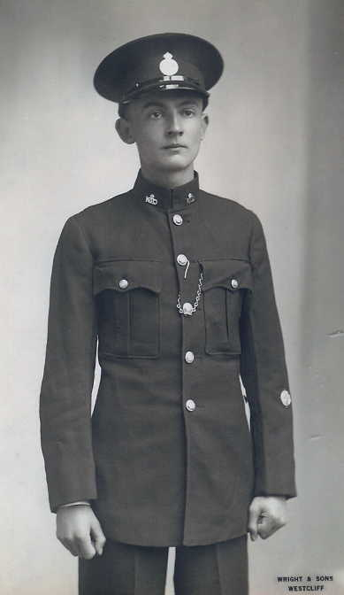
Metropolitan Special Constabulary Division, "Shell" Company

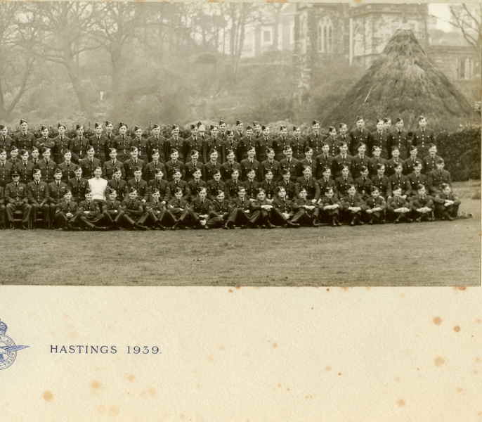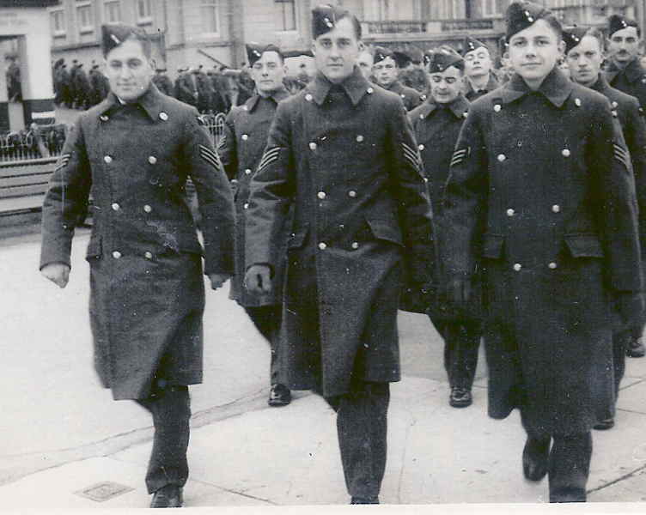
By June 1939, age 18, Cliff had signed up with the R.A.F.V.R. into No 3 I/T Wing (Hastings). They did their book learning at Marine Court, St Leonards on Sea and marched around the town.
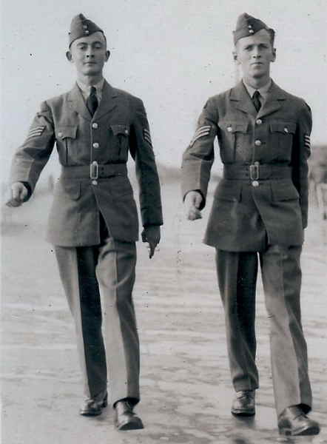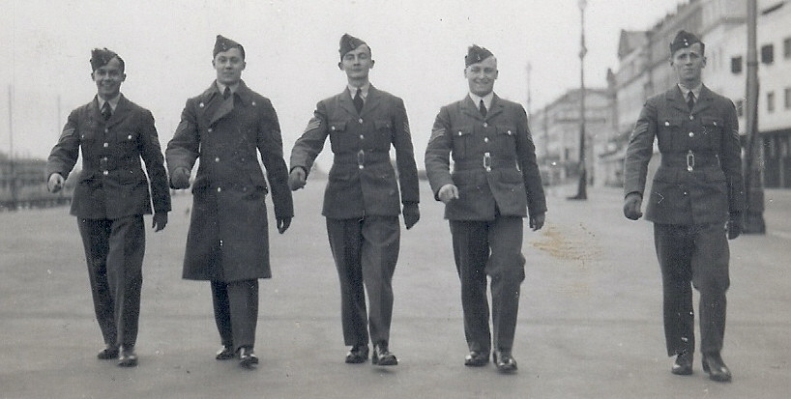
On 1 Sep 1939 Cliff was accepted for pilot training initially, then transferred to air gunner training: RAF Sgt. Pilot 754129. D Flight No 3 Wing St Leonards (Cliff is 8th in from the left in 2nd to top row)
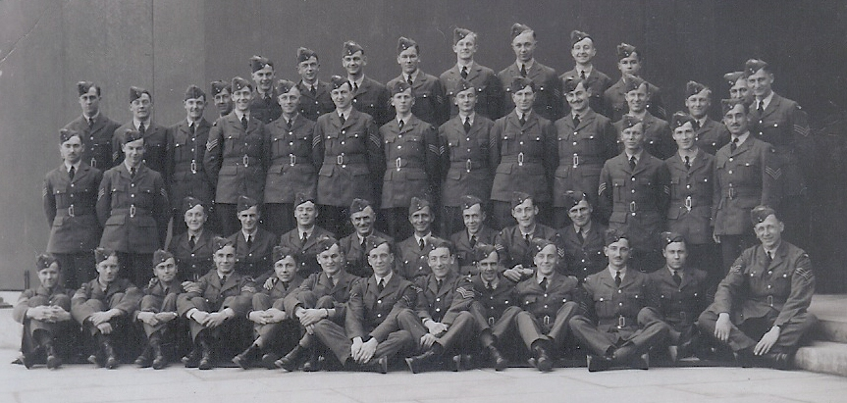
Handley Page Harrow Aug to Sept 1940 at No 8 Bombing & Gunnery School RAF Evanton
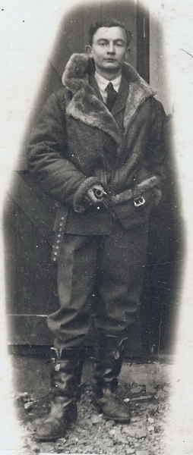 Pilot Officer Hine Age 20

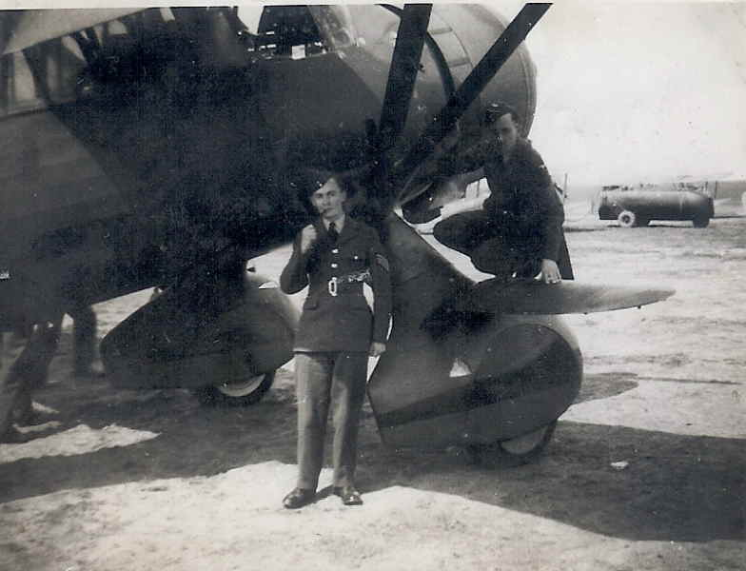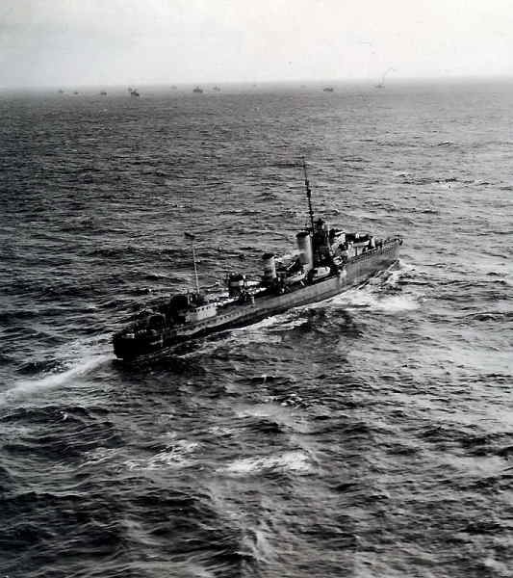
Aerial photo by Cliff Hine

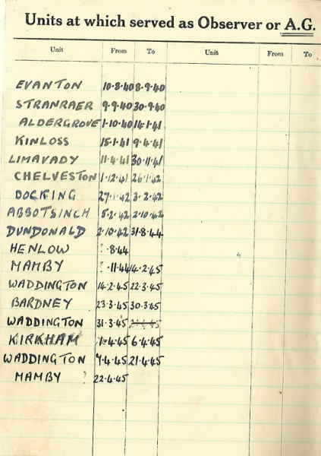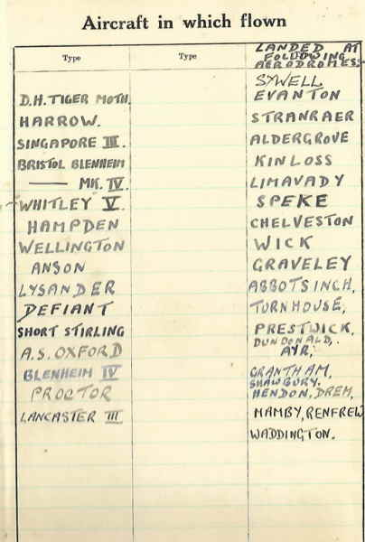
Excerpts from Cliff's Log Book (1940-1945 20

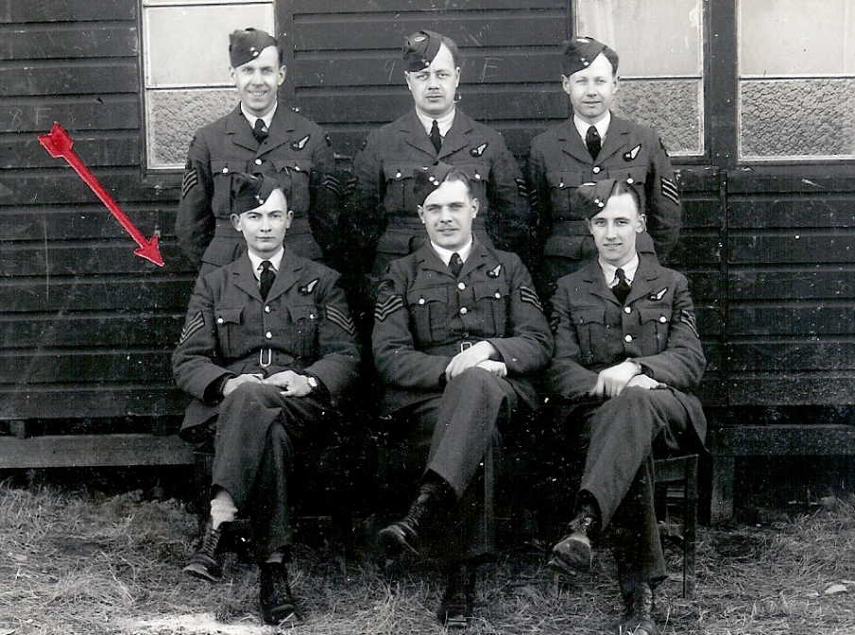At Kinloss Airfield, awaiting instructions to bomb Narvik (mission was cancelled)
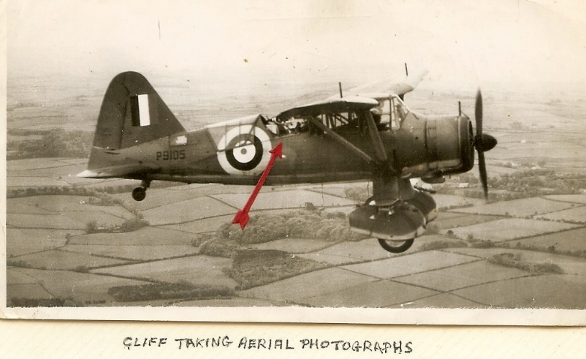
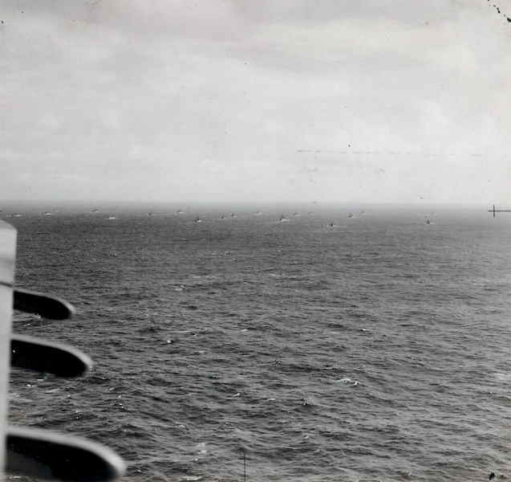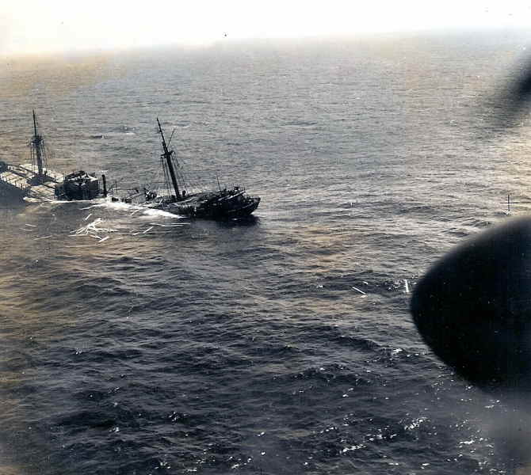

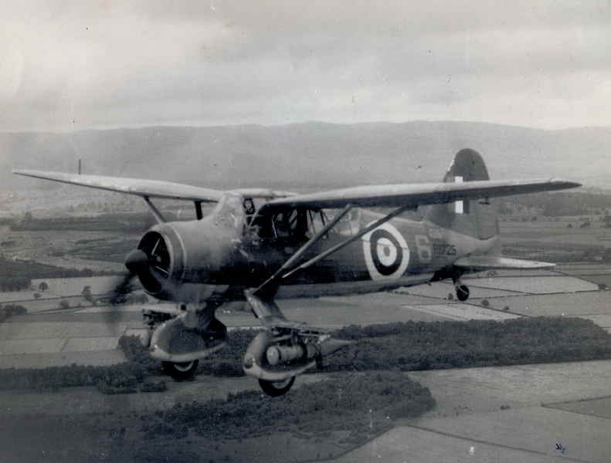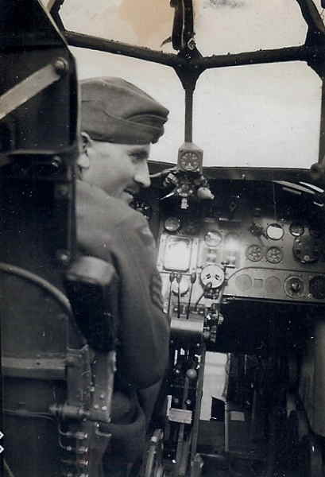

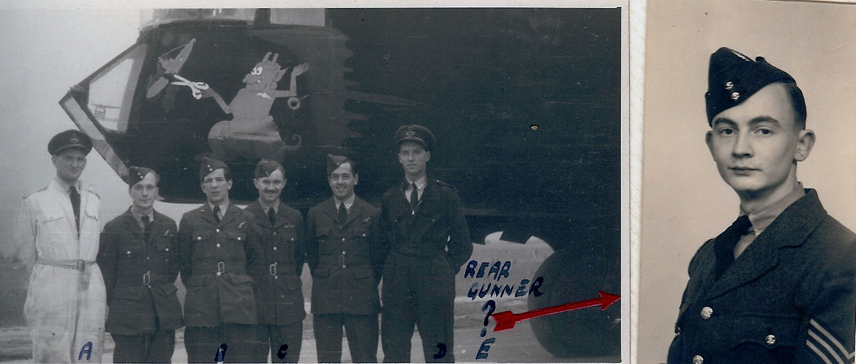
Combined Ops. P/O Smokie Joe Hine missing from picture

  - 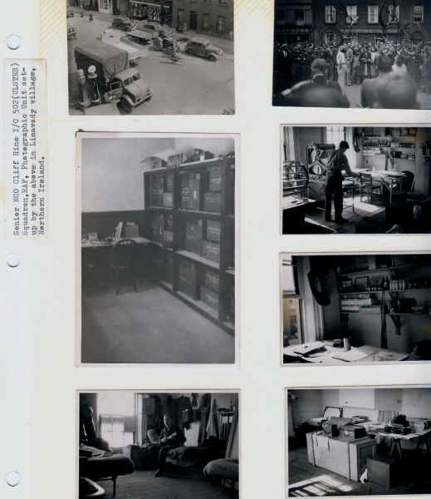
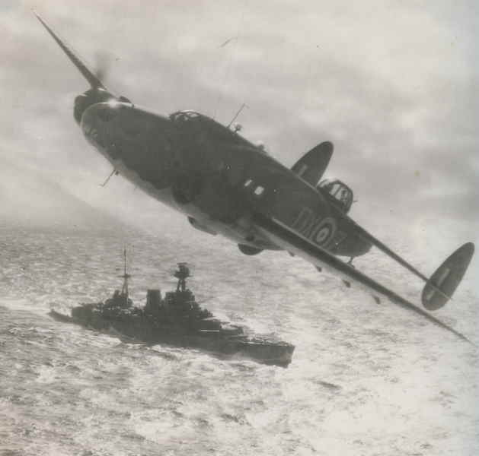
The Atlantic, 9 August 1941: Winston Churchill and Franklin Roosevelt met on board HMS Prince of Wales off Newfoundland (photo by Cliff Hine from the Whitley, 502 (Ulster) Squadron)

  - 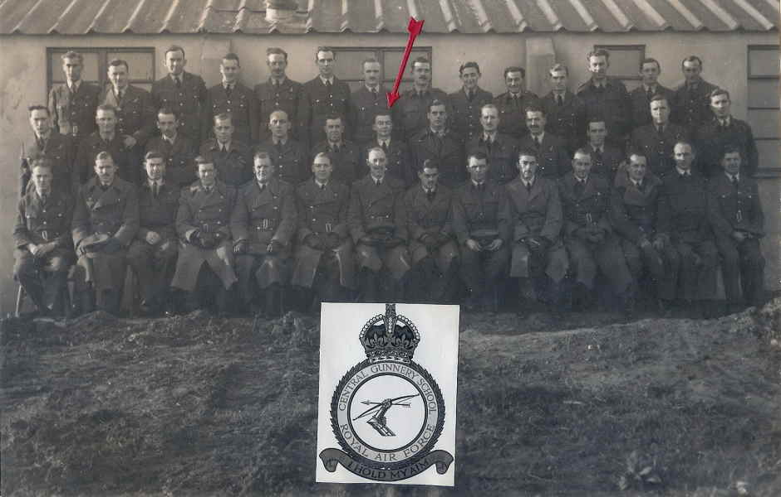
Air Gunner Leaders Course, Central Gunnery School, RAF Chelverston (1941)

D Flight No 3 Wing
  - 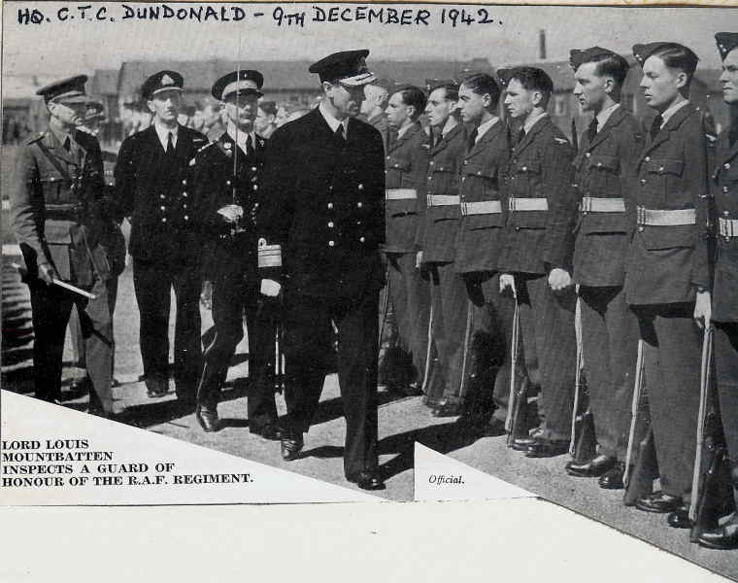

Cliff taking aerial photos c1942

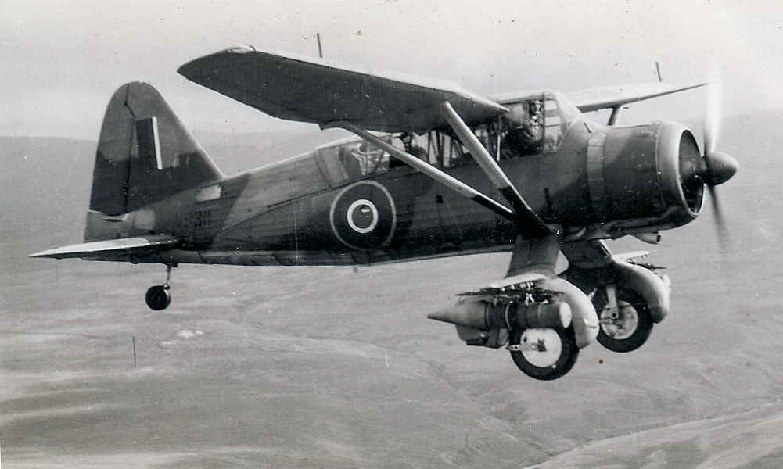

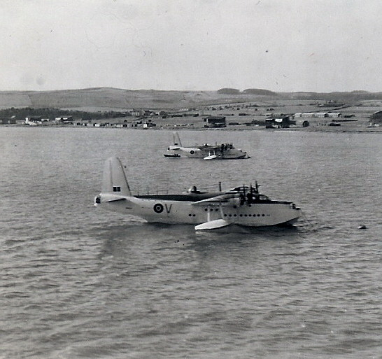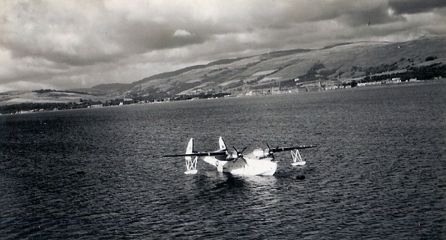
  - 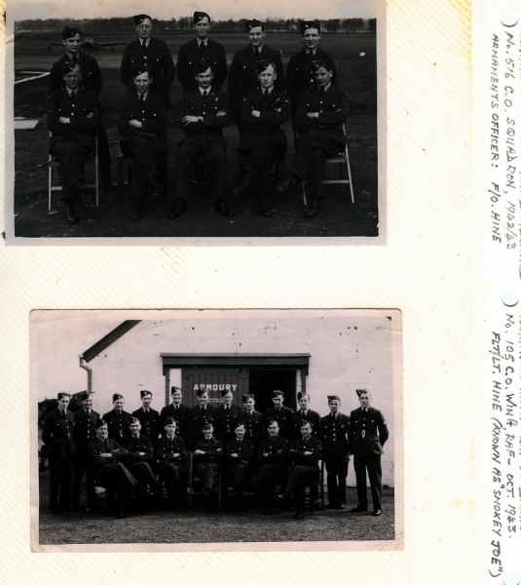

  - 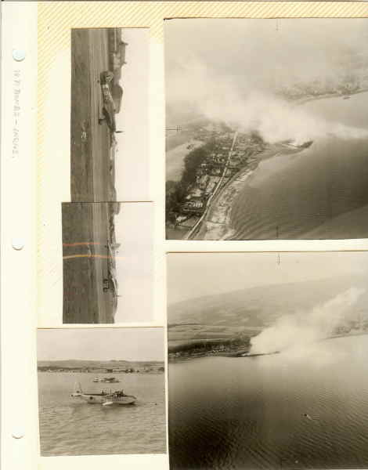

  - 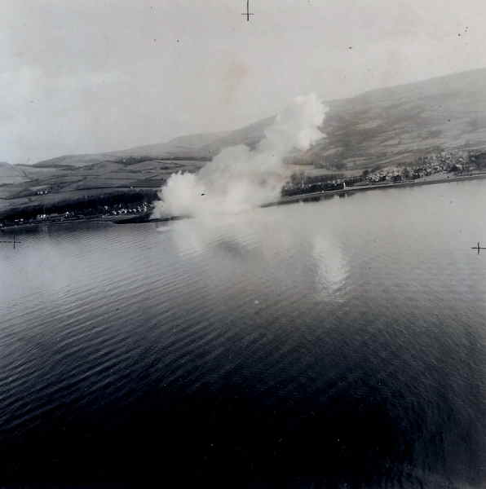

  - 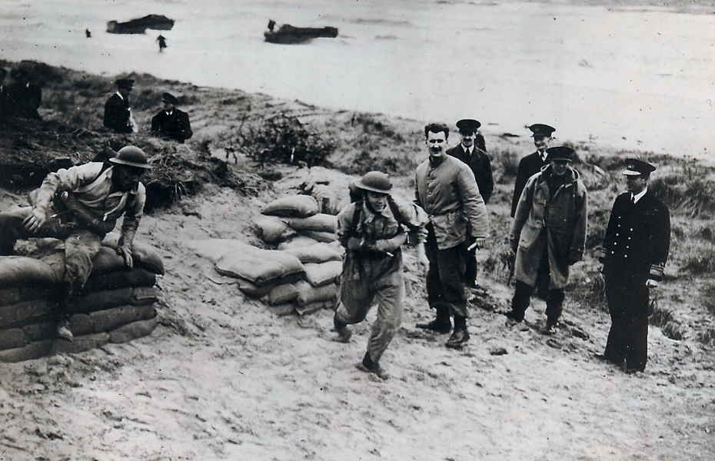

  - 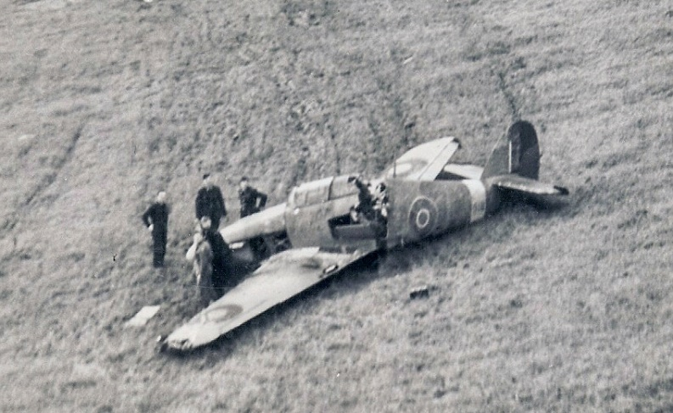

23 Feb 1942: RAF Abbotsinch, Scotland (144 Flight): Flying in Anson DG903 with Pilots Sgts. Aspinall and Stephens (Cliff had taken photos at Inverary as detailed); undercarriage of Anson U/S so they had to make a crash landing.

  - 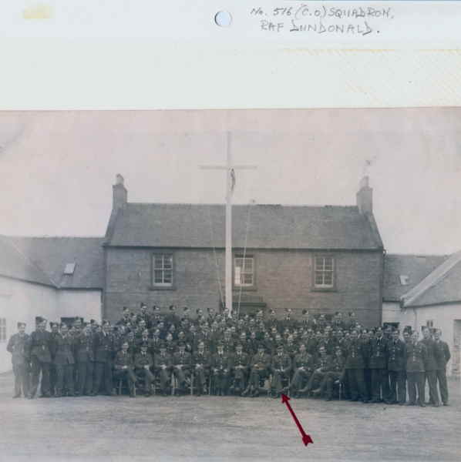

April 1943 • No 516 (CO) Squadron, Dundonald, Ayrshire

  - 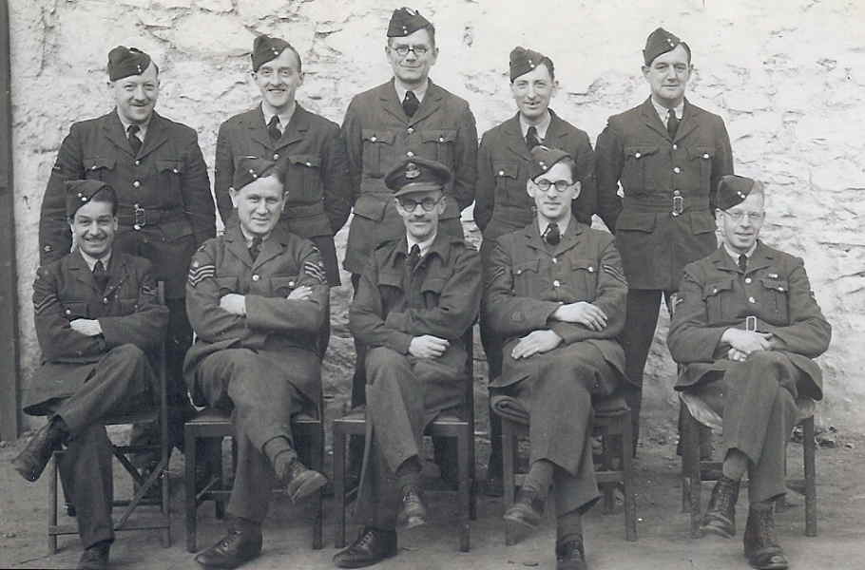

  - 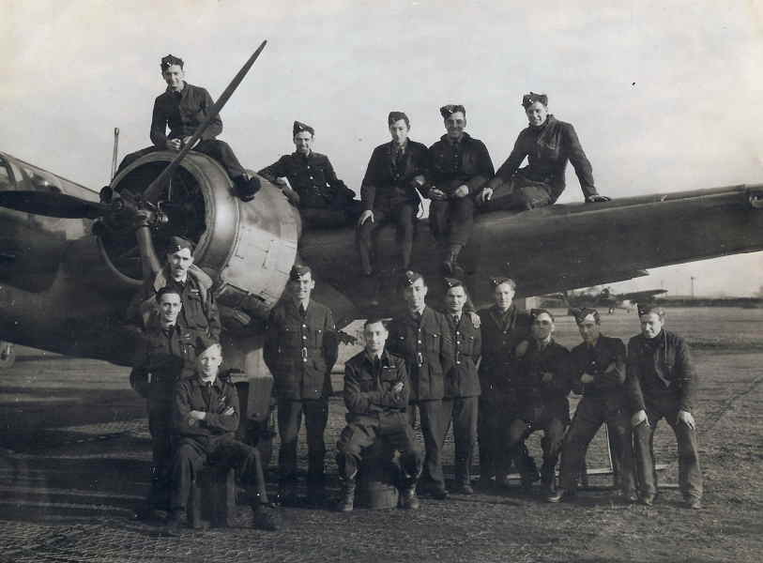

  - 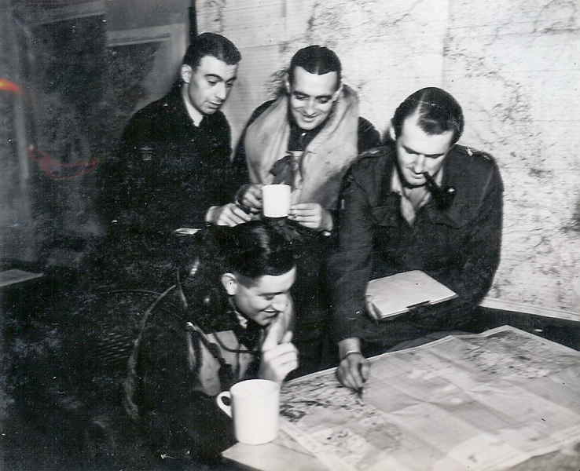 1942 Combined ops:

4 April 1942: 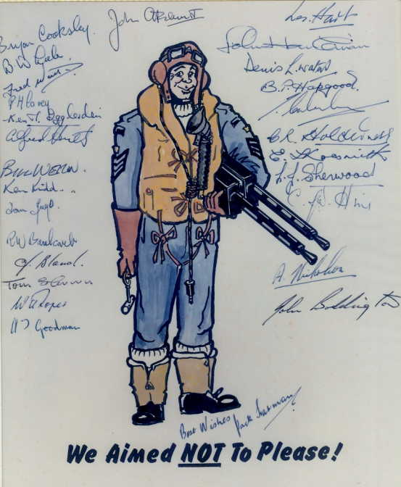

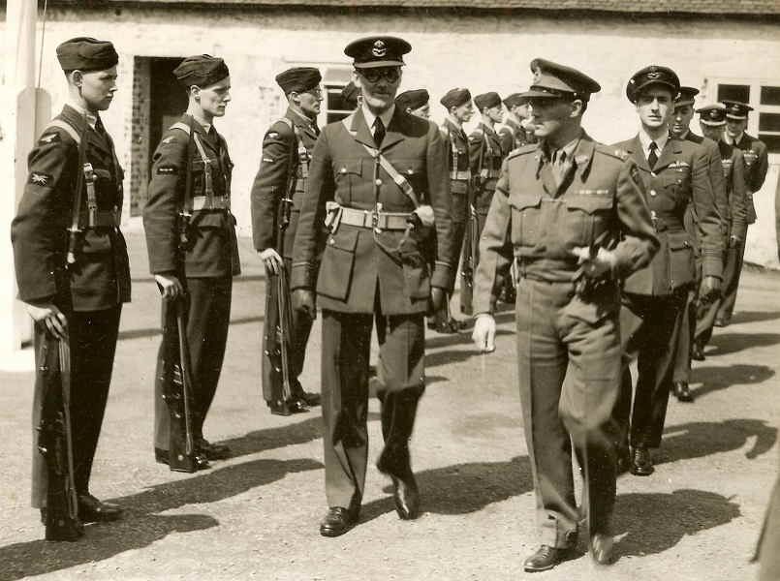 RAF Dundonald Combined Ops
Lord Mountbatten visits Combined Ops; also visits by Duke of Gloucester and Maj Gen Laycock

  - 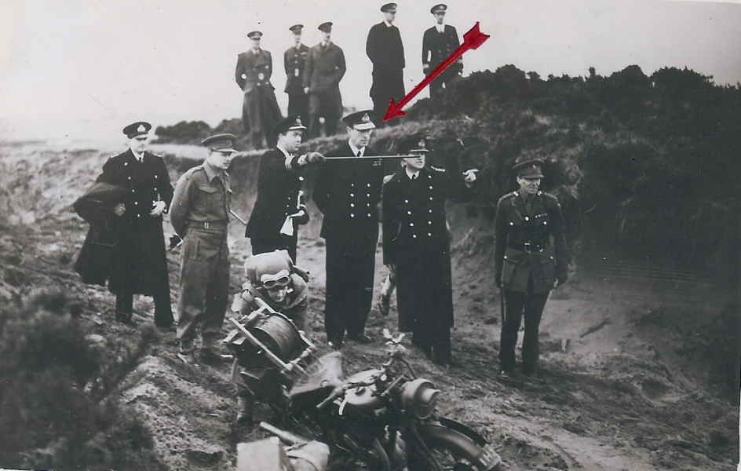

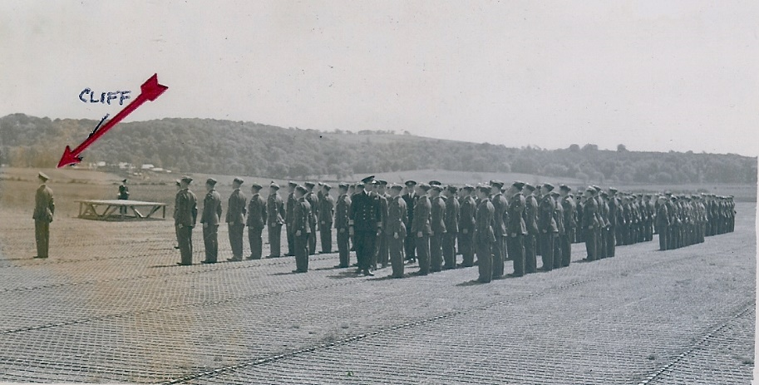
Lord Mountbatten visits Combined Ops Dundonald June 1943

Lord Mountbatten visits Combined Ops Dundonald June 1943: Cliff on Parade

  - 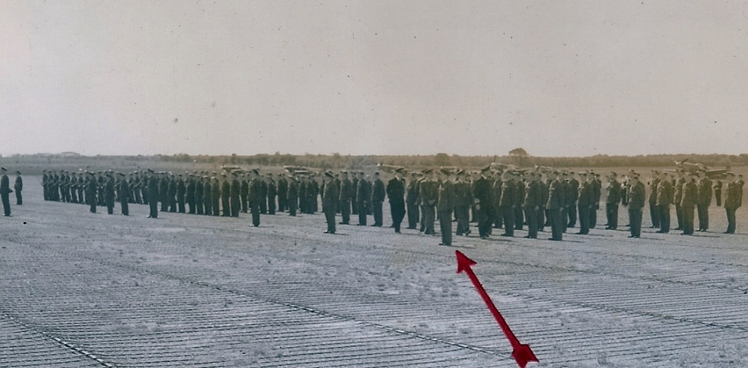

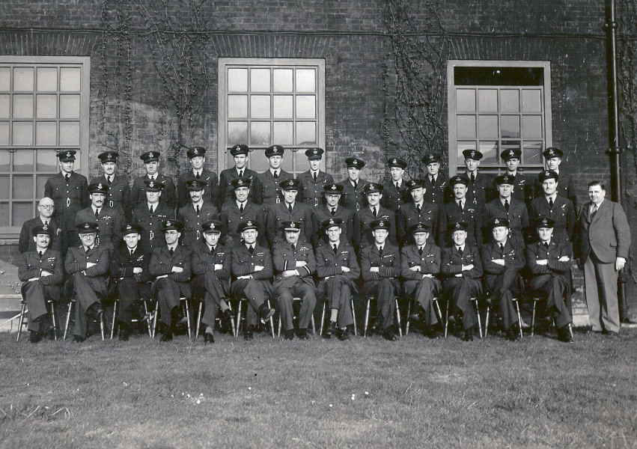

Armament Section RAF Dundonald
Known as F/O 'Smokey Joe' Hine 516 (C.O.) Squadron Armaments Officer & Gunnery Leader, RAF Dundonald (1942/43)

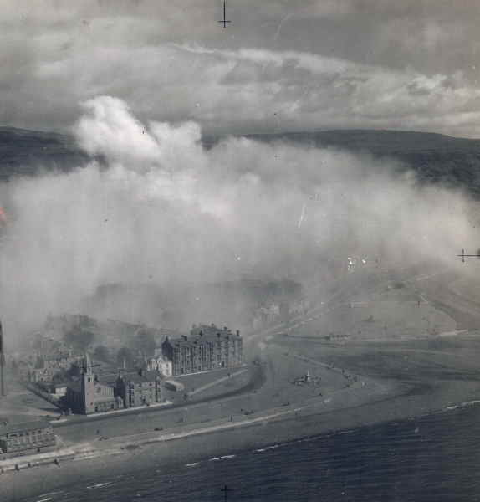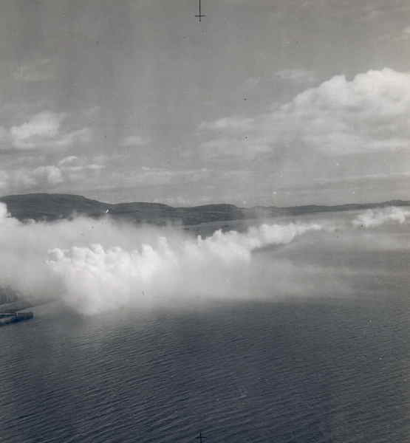

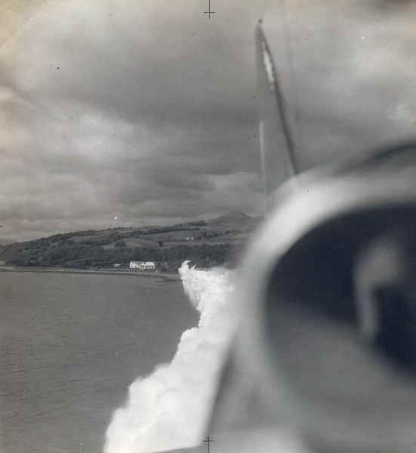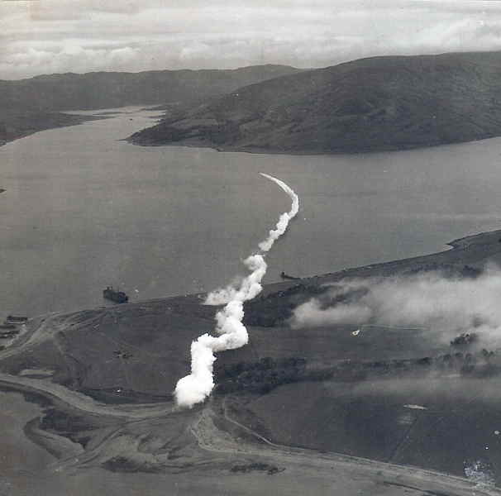
  - 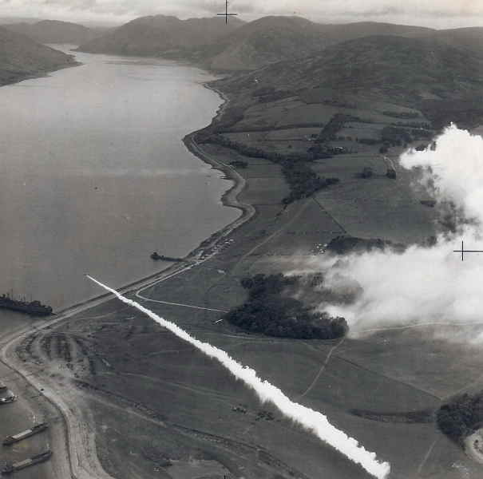

  - 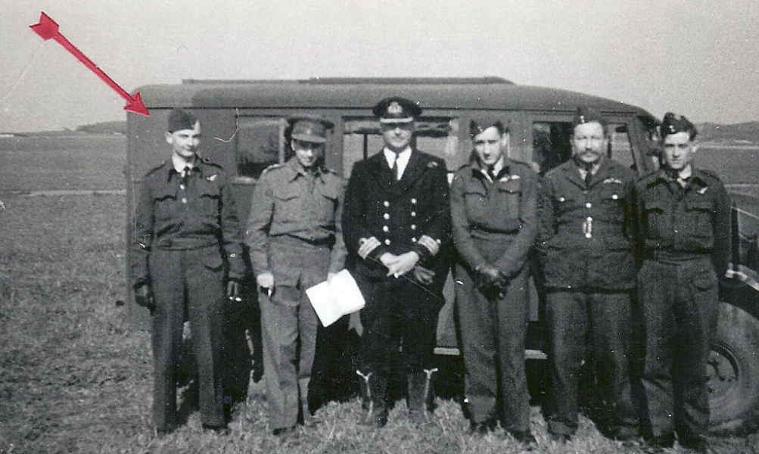
  - 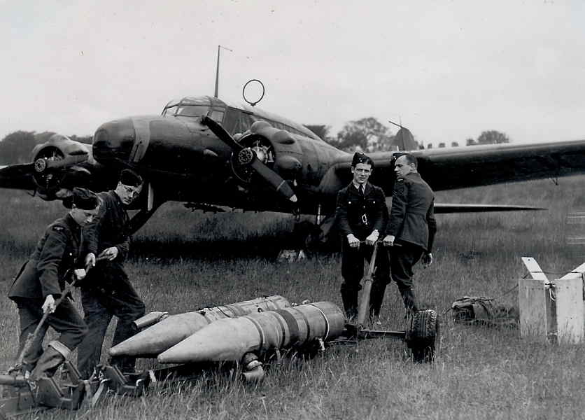
  - 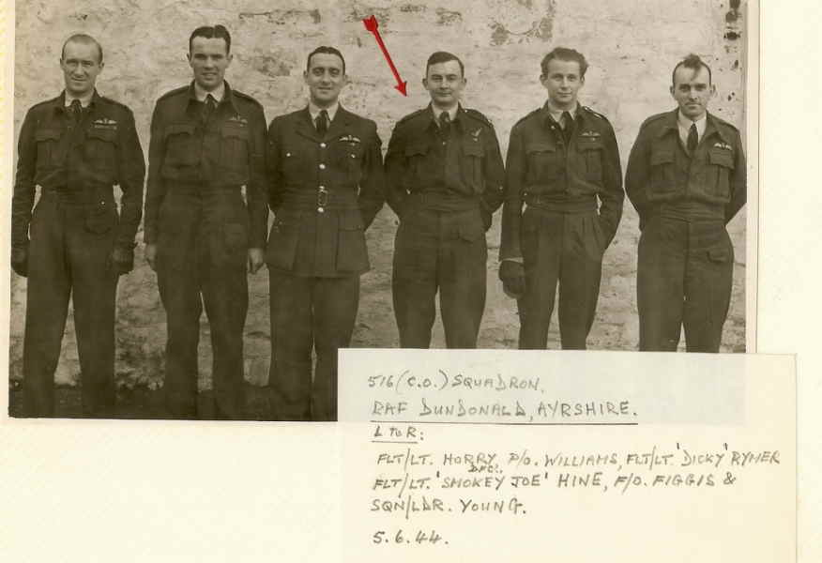
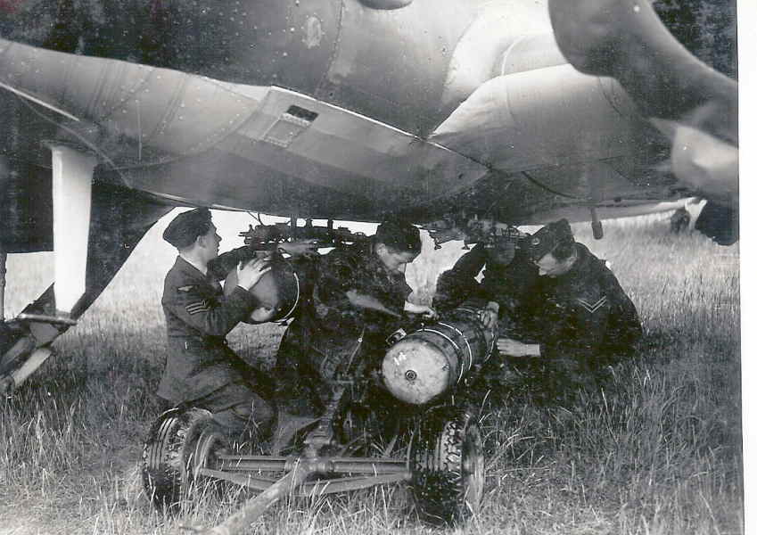
Full time Armament duties 18 Jan 1944 - Aug 1944 • Dundonald

- MAY
Cliff with brother Deryk on home leave May 1944

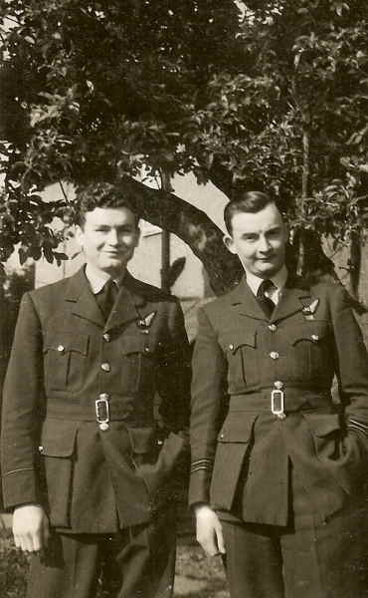

  - 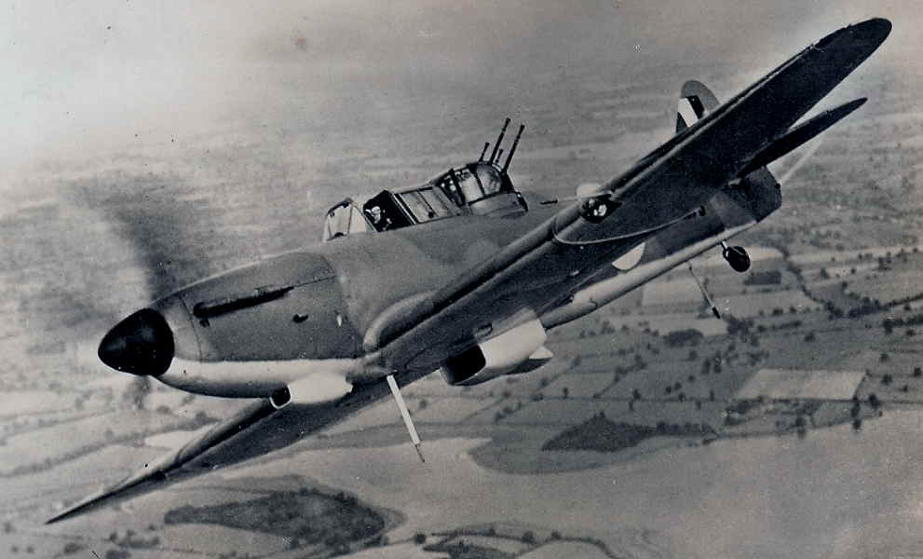
  - 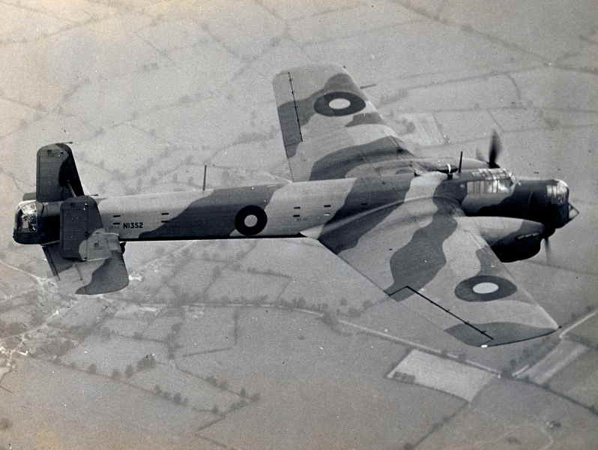
  - 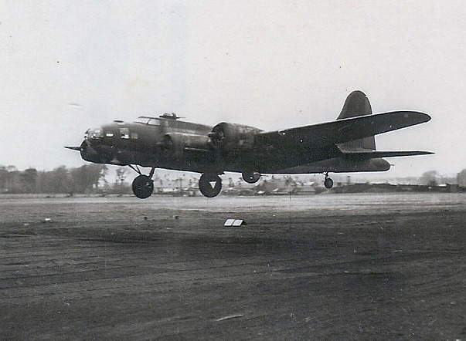
  - 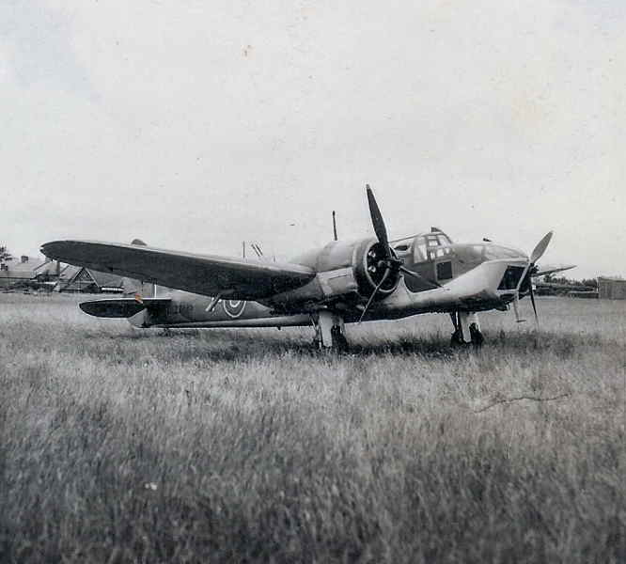

  - 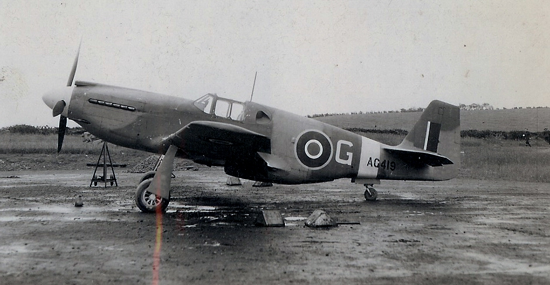
  - 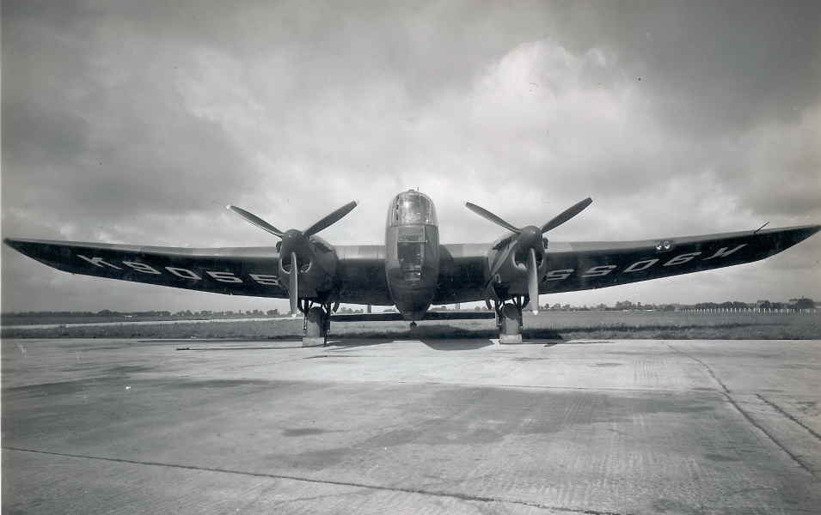

No 12 Armament Officers Course RAF School of Aeronautical Engineering, Oct. 1944. See photo (arrows in red) of Clifford & Ken Wallis (of autogyros fame and "Little Nellie" filming/stunts in James Bond films)

  - 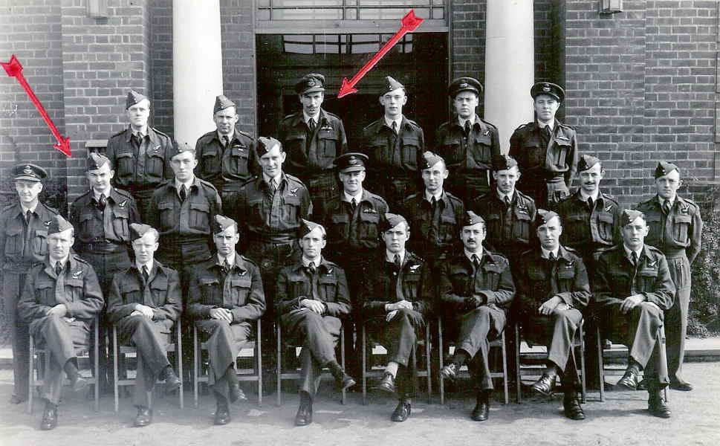

Oct 1944 RAF Mamby Clifford attended Specialist Armament Officers Course

  - 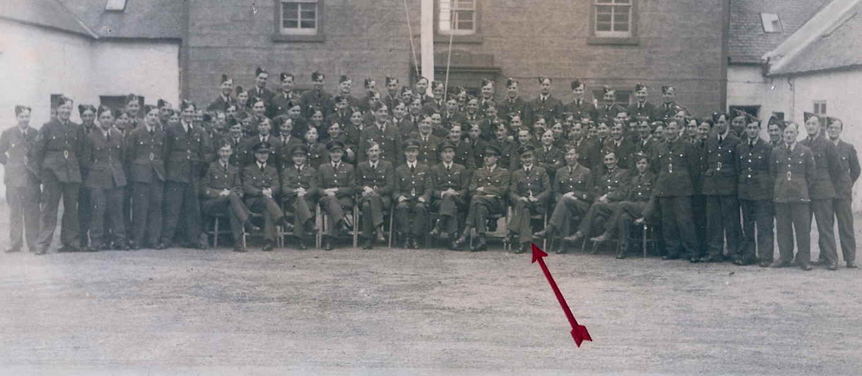

  - 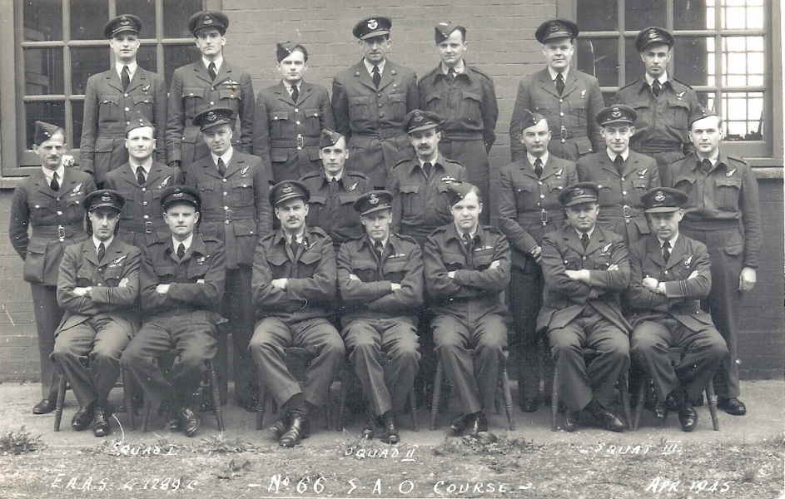

- 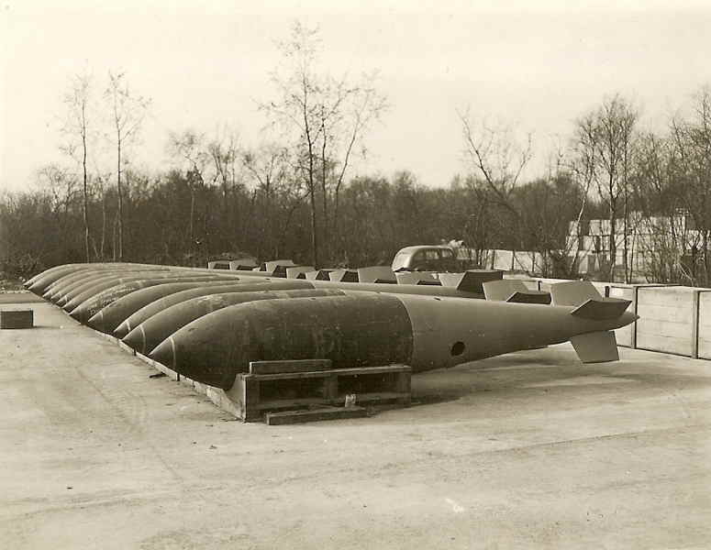

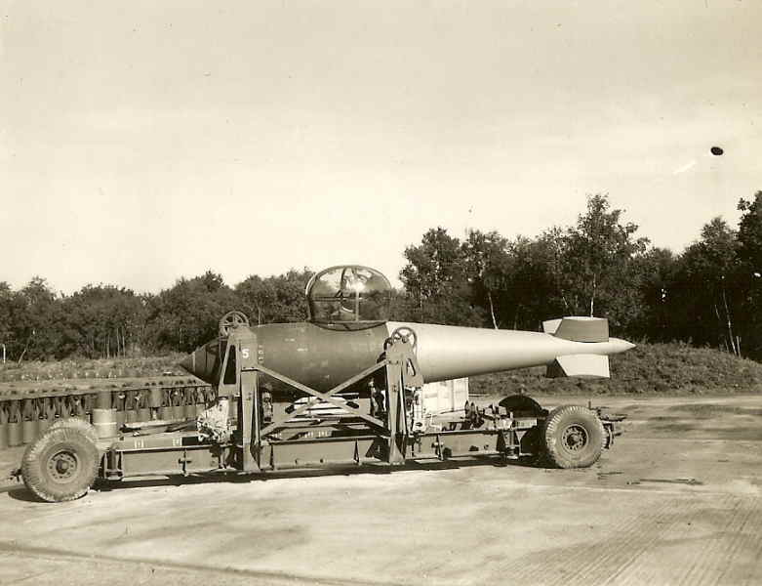

  - 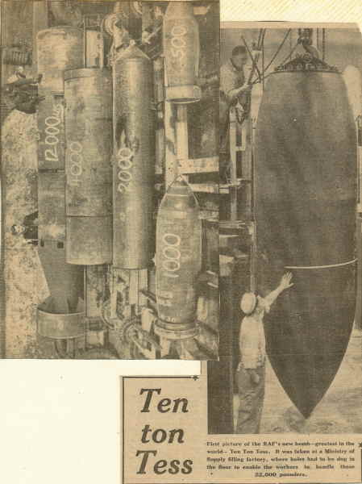

Armaments Section
  - 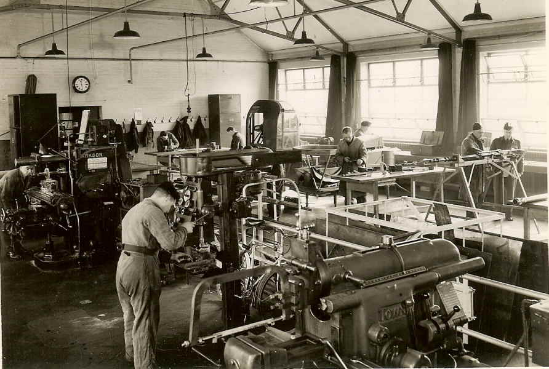

1944
Drawing by AS Burns 1944 in same squadron as Cliff in the RAF:

  - 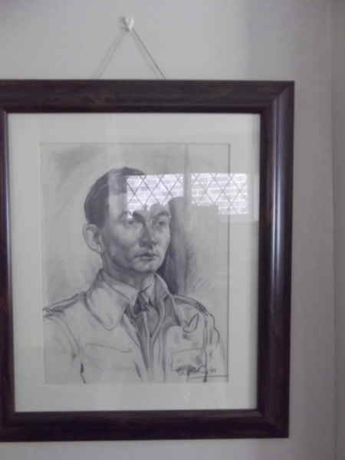

RAF Mamby Apr 1945 No 66 SAO Course (Cliff mid row 3rd in from right)

  - 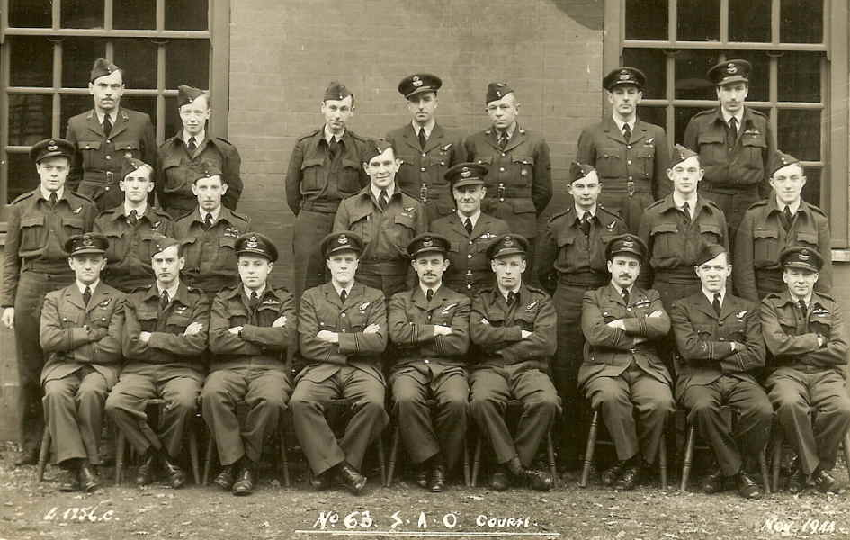

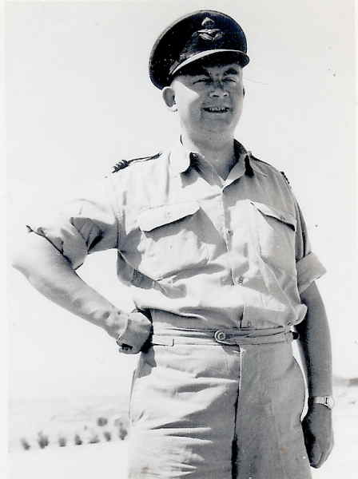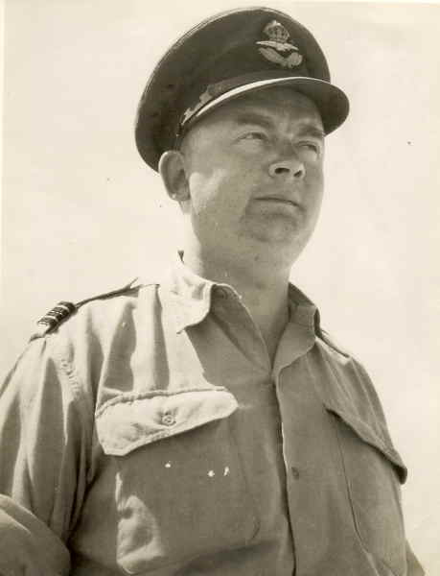
1 April 1956: Recalled to Active List HM Forces for duties in Cyprus for Air and Military Intelligence and Security Services. Known as "Foxy" Hine

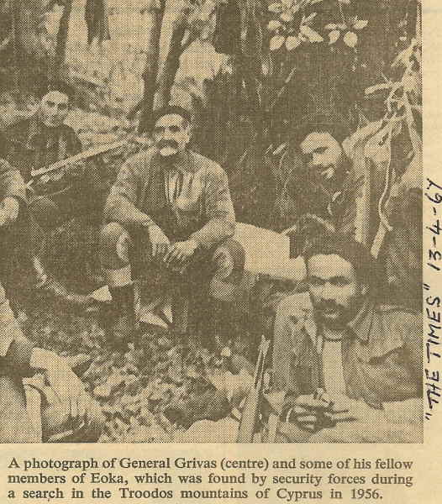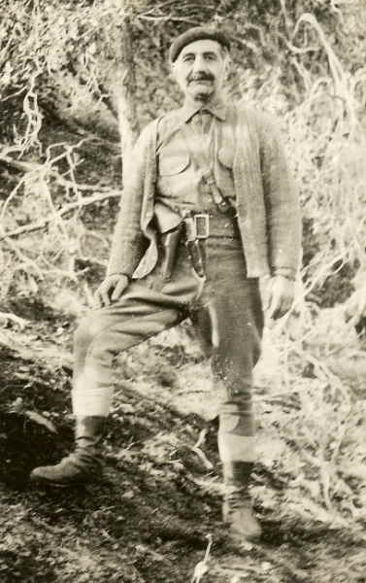

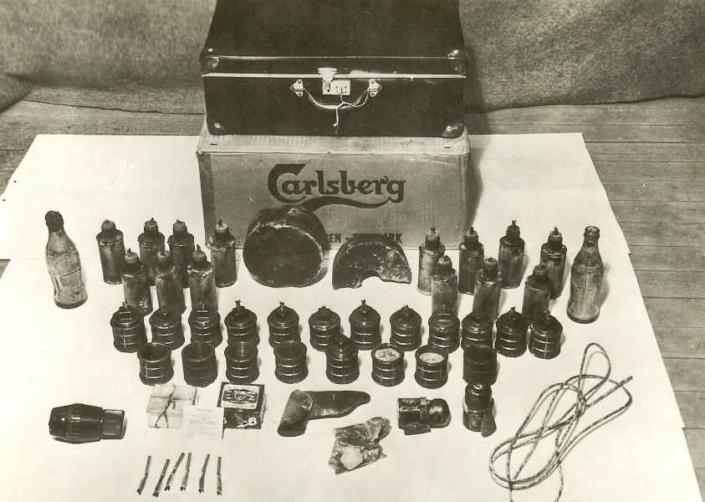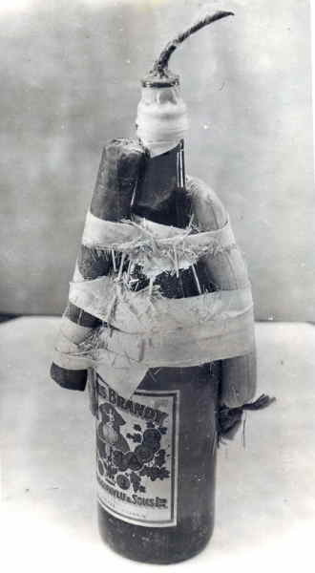
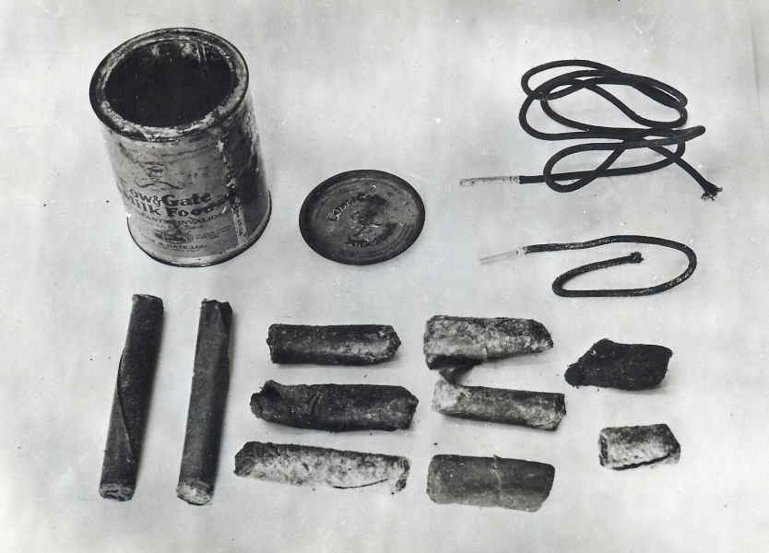

25 June 1956

